**To learn basic commands in GIT**

Mkdir :-COMMANDS CREATE ONE OR MORE DIRECTORY.



Pwd :- COMMAND USED TO PRINT WORKING DIRECTORY.

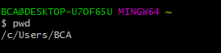

Cd:- COMMAND USED TO CHANGE DIRECTORY.

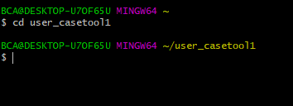

Reset:- COMMAND USED TO CLEAR GIT BASH SCREEN.

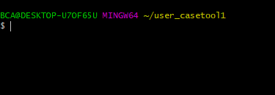

**NOTE:-**

The MINGW64 is the value from the MSYSTEM environment variable.

Mkdir folder1 folder2:- To create more than one directory.

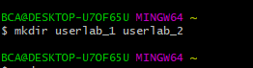

Git init :- to create new repository



Git --version :- To check gitbash version

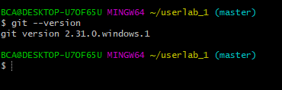

The git config command sets the author name and email address to be used with yours commits.

git config --global user.name "Amogh"

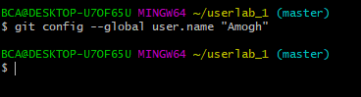

git config --global user.email [amoghvadkar17@gmail.com](mailto:amoghvadkar17@gmail.com)



The touch command creates a new empty file.

touch add.txt

touch add.html

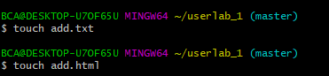

The git add[file] command adds a file to a staging area.

Git add add.txt



The git add * adds one or more files to a staging area.



Echo “put any content”>>add.txt commands adds content in text file.



Git rm [file] command delete the file from your working directory and stages the deletion.



The git commit –m “[type message]”command records or snapshot the file permanently in the version history

1

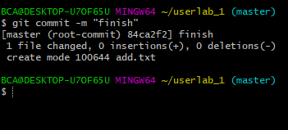

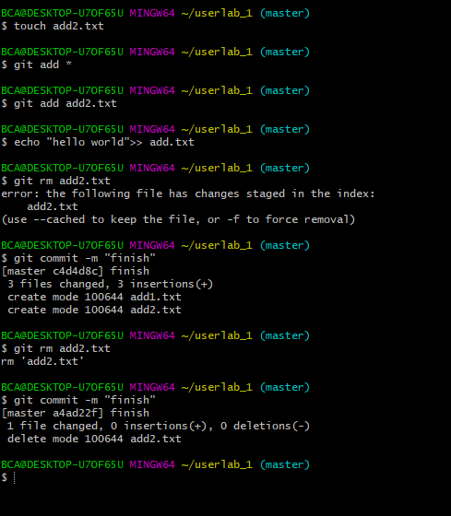

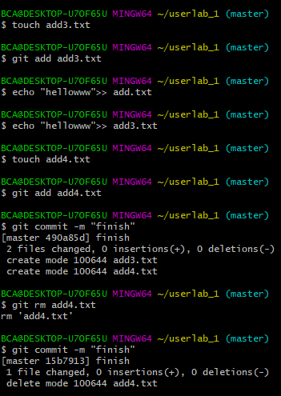

The git commit -a command:- commits any files you’ve added with the git add command and also commits any file you have changed since then.

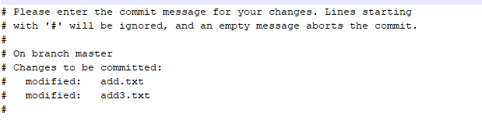

ll is used to count the total number of files in current working directory .

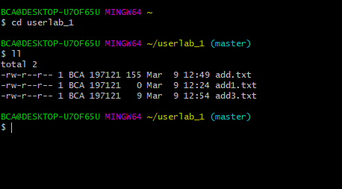

Ls is used to ‘list’ content of current working directory.



Git branch [branch name] creates a new branch.

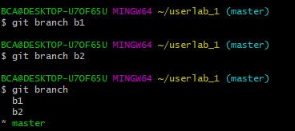

The git branch command lists all the local branches in the current repository.



The git branch –d [branch name] deletes the feature branch.



Git checkout[branch name] command is used to switch from one branch to another

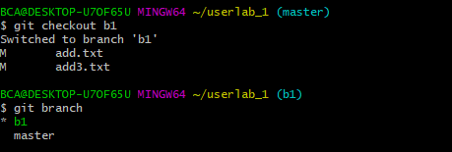

Git checkout –b[branch name] creates a new branch and also switches to it

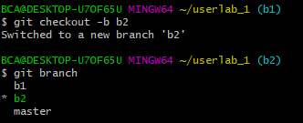

The git log command is used to list the version history of the current branch.

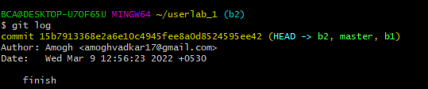

The git status lists all the files that have to be committed.

